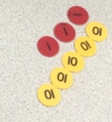
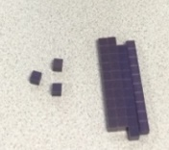
Maths at Ashlands Primary School
Intent:
At Ashlands primary school we believe that maths is a fundamental corner stone of our curriculum, which is accessible to all and will maximise the development of every child’s ability and academic achievement. The basic skills of mathematics are vital for the life opportunities of our children.
Our aim is for all children to think mathematically, enabling them to reason, solve problems, and make connections that they will need in their everyday lives.
We will
- implement the current legal requirements of the Foundation Stage (FS) and the National Curriculum (NC).
- foster positive attitudes, fascination and excitement of discovery through the teaching and learning of mathematical concepts.
- ensure pupils become fluent in the fundamentals of mathematics, developing conceptual knowledge and an ability to recall and apply knowledge rapidly and accurately
- ensure that pupils can reason mathematically and solve problems
- strive for children to develop a ‘can do’ attitude and perceive themselves as mathematicians.
- broaden children’s knowledge and understanding of how mathematics is used in the wider world.
- teach children to use and understand mathematical language and recognise its importance as a language for communication and thinking.
Implementation:
Our Mathematics Mastery curriculum has been developed to ensure every child can achieve excellence in mathematics. It provides pupils with a deep understanding of the subject through a concrete, pictorial and abstract approach. This ensures pupils fully understand what they are learning. We follow the White Rose Maths schemes of learning, as it ensures a progressive maths journey that facilitates the coverage for each year. Our teaching staff use these documents in conjunction with a range of other useful resources to guarantee interesting and varied lessons.
Impact:
Children will enjoy mathematics. They will have a toolkit of skills and strategies that they can use when faced with a mathematical problem. We want all children to leave our school as confident mathematicians, achieving the best of their ability and ready to face mathematical challenges in the wider world.

