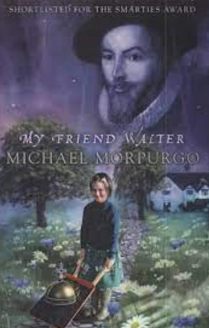

‘My Friend Walter’, tells the story of a girl called Bess, who meets a stranger at a family party and tells her to visit the Tower of London. Here she meets the ghost of Sir Walter Raleigh, who also happens to have been the stranger at the party and a distant relative. He asks Bess if he can go and live at her house. Being a ghost, he gets up to all sorts of mischief! I love this book.

**Title: My Friend Walter**

**Author: Michael Morpurgo**

**Illustrator:**

**Genre: Historical fiction**



**Miss Raine Recommends…** 