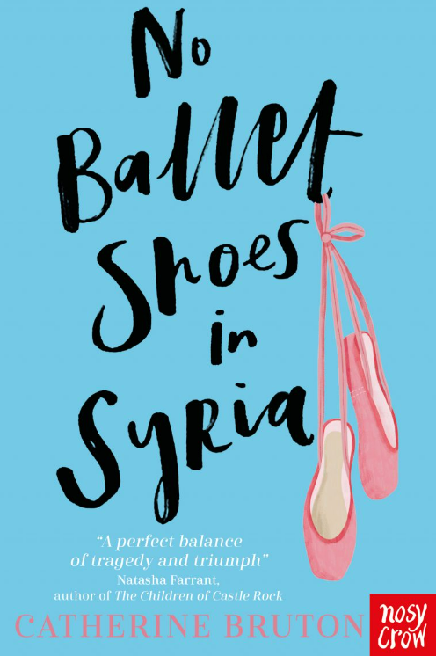

This is the story of Aya, an 11-year-old asylum seeker from Syria, who has just arrived in Britain with her mum and baby brother.

It is a moving and thought-provoking story of hope and kindness, which was recommended to me by a child in Year 5. I thoroughly enjoyed reading it, and I hope you do too!

**Title: No Ballet Shoes in Syria**

**Author: Catherine Bruton**

**Illustrator:** **Elisabetta Barbazza.**

**Genre: Fiction**



**Mrs Barrott Recommends…** 