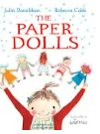

love this fun book with great characters and lovely adventures with the main character. The book then takes an unexpected turn and you think things will never be the same again. Don’t worry, the story just changes as new characters appear and new adventures happen.

m

**Title: The Paper Dolls**

**Author: Julia Donaldson**

**Illustrator: Rebecca Cobb**

**Genre: Childhood Imagination**



**Mrs Dalton Recommends…** 