**Title: The Girl who Stole an Elephant**

**Author: Nizrana Farook**

**Illustrator: David Dean**

**Genre: Adventure**

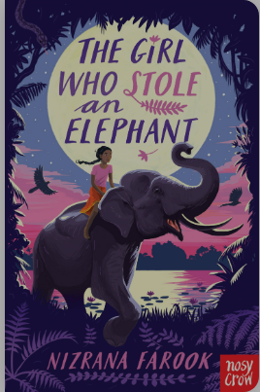

This great adventure story has an exotic setting and is a real page-turner. The characters are fun and original. Chaya is rebellious a girl who is lively, brave, and never far from trouble. Her best friend Neelan is a quiet, intelligent, thoughtful boy who tries desperately to keep Chaya on the right track (not always very successfully). Nour is a character who surprises the reader (and Chaya) at every turn.



**Mrs Pearce Recommends…** 