**Title:** The Lion, the Witch and the Wardrobe

**Author:** C. S. Lewis

**Illustrator:** Pauline Baynes

**Genre:** Fantasy/Adventure

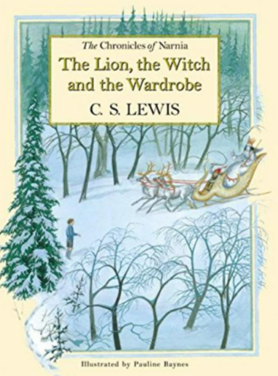

As a child I loved to read fantasy and adventure books and The Lion the Witch and the Wardrobe was my absolute favourite. The idea of being able to walk into a wardrobe and be transported into another world completely captivated me. I loved C.S. Lewis’ description of the magical land of Narnia, with its pine forests covered in a crisp blanket of snow -where it was forever winter, but never Christmas.



**Mrs Rose-Jackson Recommends…** 