**Title: Michael Recycle**

**Author: Ellie Bethel**

**Illustrator: Alexandra Colombo**

**Genre: Fiction**

This is a great book with an important message~ ‘Recycling is everyone’s business.’

My children love reading this with their grandparents and reminding them to recycle!

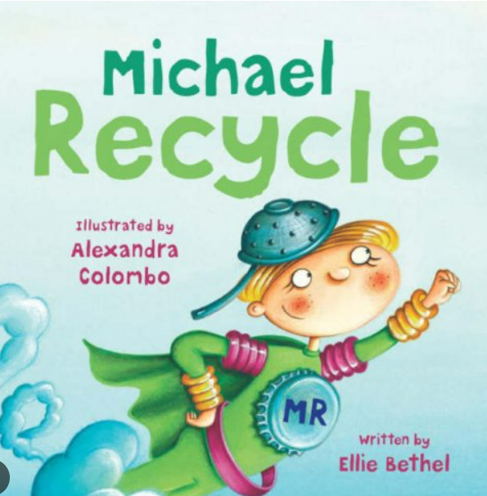

**Mrs Russell Recommends…** 