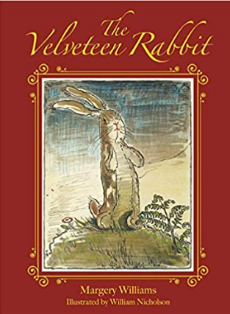

**Title: The Velveteen Rabbit**

**Author: Margery Williams**

**Illustrator: William Nicholson**

**Genre:** Fiction



What does it mean to be real? This is the story about a new toy to a nursery

who wants to know the answer to this question? Will the Velveteen rabbit ever become real? Find out by reading this book!

**Mrs Shepherd Recommends…** 