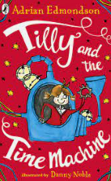

When Tilly's dad builds a time machine in the shed there's only one place she really wants to go: back to her birthday party, when her Mum was still here. But then something goes wrong and Tilly has many adventures throughout history on the way! Will she ever find her Mum and make her way back to the present?

**Title: Tilly and the Time Machine**

**Author: Adrian Edmondson**

**Illustrator: Danny Noble**

**Genre: Adventure**



**Mrs Thompson Recommends…** 