

**Title: Gangsta Granny**

**Author: David Walliams**

**Illustrator: Tony Ross**

**Genre: Comedy**

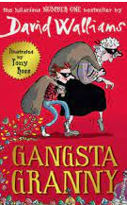

This story is a perfect mixture of fun, enjoyment, humour and curiosity!

The story starts with the main character, Ben, being bored after he is told to stay at his Grandma’s house – she’s so boring! But what Ben doesn’t know is that his Grandma was once an international jewel thief and she now wants to steal the Crown Jewels. Only she needs Ben’s help to do it!

**Mrs Wood Recommends…** 